# Week 3 Class exercise

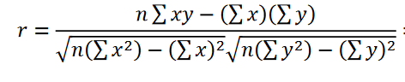

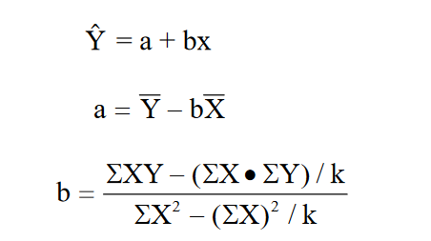

# Questions

## Q1. Calculate coefficient correlation of below data

|  |  |  |
| --- | --- | --- |
| Observation | x | y |
| 1 | 11.8 | 10.4 |
| 2 | 12.5 | 16.5 |
| 3 | 15.7 | 22.9 |
| 4 | 9.2 | 26.6 |
| 5 | 21.9 | 33.8 |
| 6 | 12.3 | 42.8 |
| 7 | 25.5 | 44.5 |

Calculate;

a) Calculate and interpret the correlation coefficient r

b) Predict y when x is 50

1. a
2. b(slope)
3. Regression line
4. Find Y when x is 50

## Q2. Below table shows marks of two subjects for grade 6 learners. Calculate coefficient correlation R and regression line

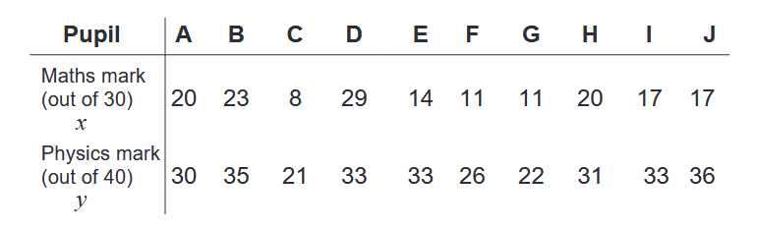

## Q3 Given below data

|  |  |  |
| --- | --- | --- |
| Observation (k/n) | x | y |
| 1 | 44 | 33 |
| 2 | 52 | 41 |
| 3 | 81 | 78 |
| 4 | 120 | 130 |
| 5 | 269 | 304 |

Calculate;

a) Calculate and interpret the correlation coefficient r

b) Predict y when x is 150

1. a
2. b(slope)
3. Regression line
4. Find Y when x is 150

Rem



## Q4. Given below data

|  |  |
| --- | --- |
| Height (Cm) | Weight (Kgs) |
| 110 | 55 |
| 115 | 56 |
| 120 | 62 |
| 132 | 63 |
| 146 | 51 |

Calculate;

1. a
2. B(slope)
3. Regression line